**Liability Product**

Found issue in "Liability Product" module in create a product. After saving the data and clicking the next button shows this error. As I have already saved the information, the next button shouldn't pop-up this error. - solved

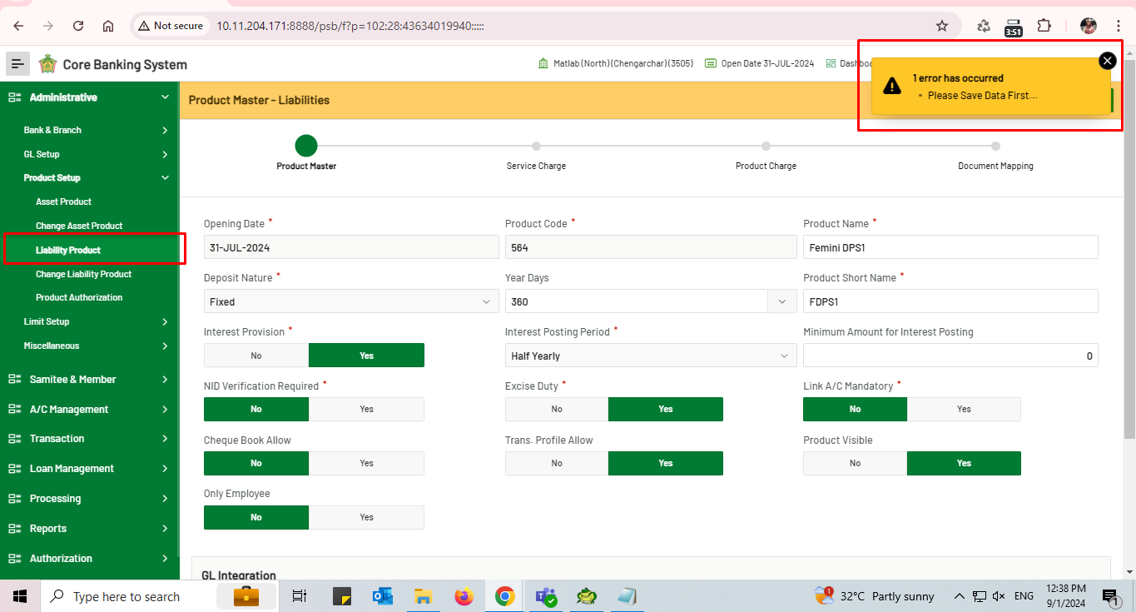

**GL Account**

"GL Account Change" module is unnecessary, as changes can be done in "GL Account Setup" module - solved

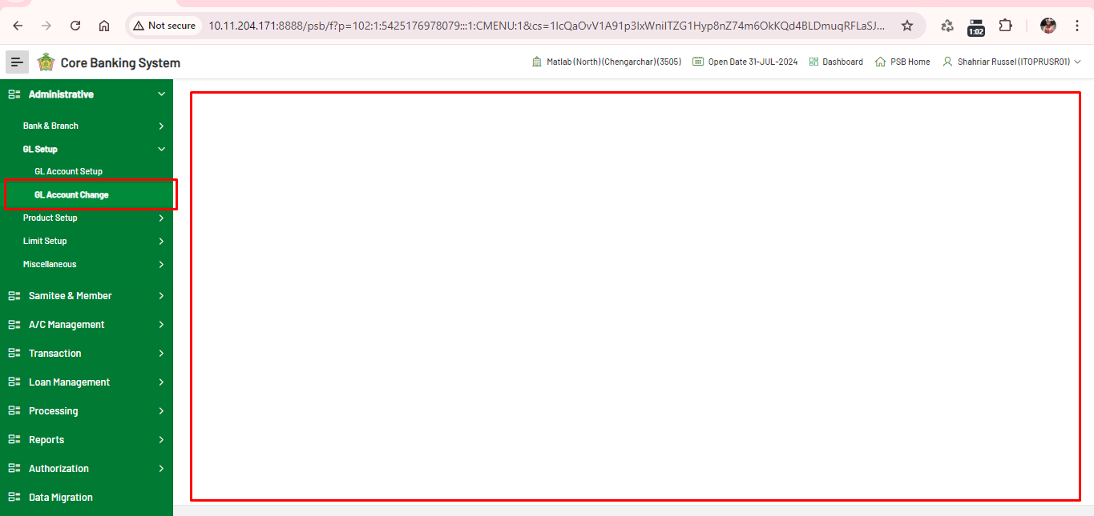

**Casa Account Close**

1. unable to download the pdf report of "A/C Statement" Report module

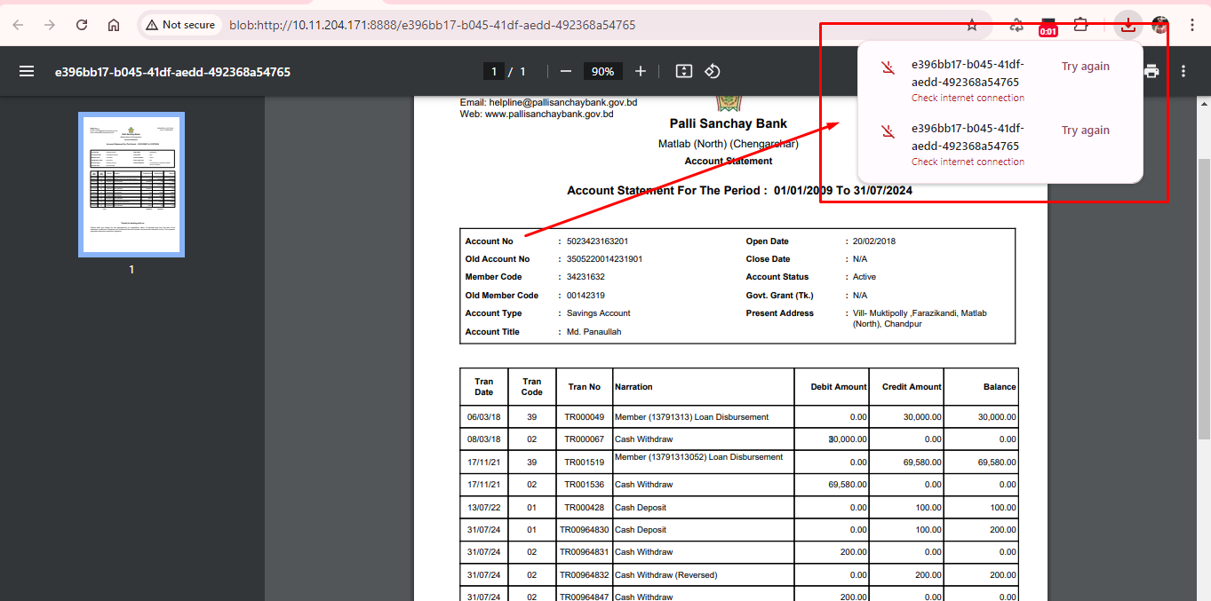

1. The system doesn't allow closing a saving account, as the balance is 0. It's a saving account, 5023423163201.

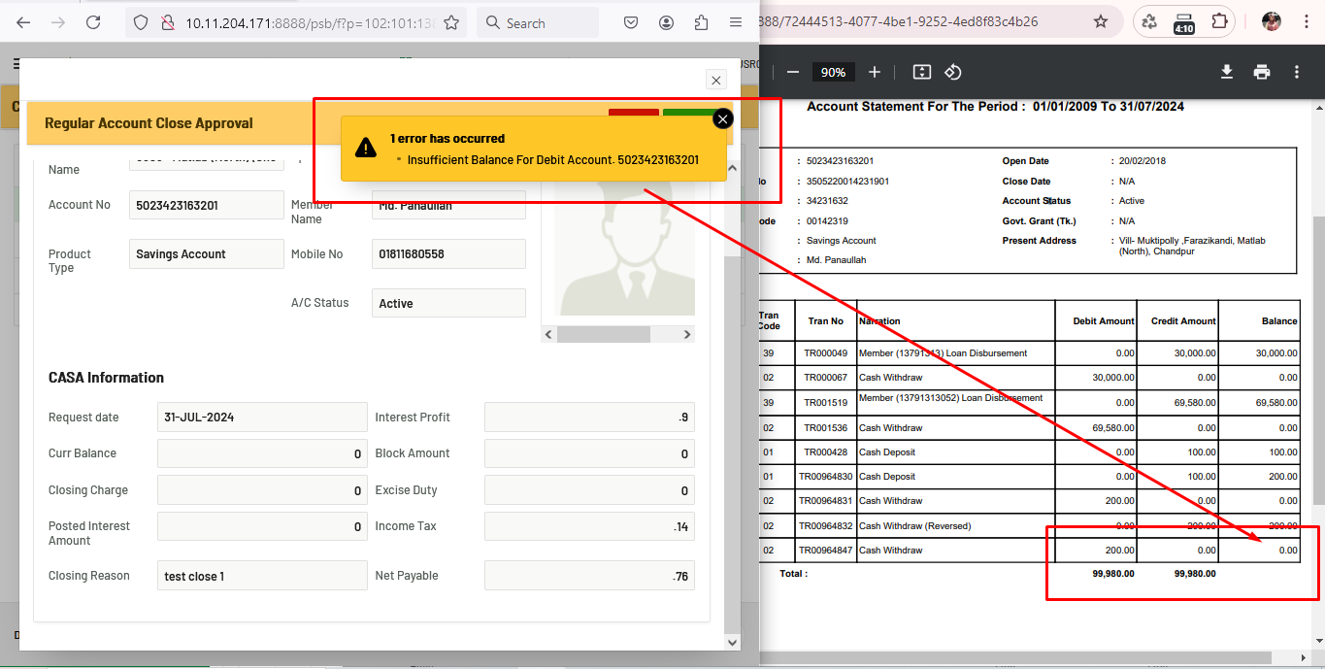

1. Can't close this account. the system showing the duplicate issue. a/c: 5023434206701, old a/c: 3505220014231901, 100265 - a/c no. It's on 3505 branch and test server.

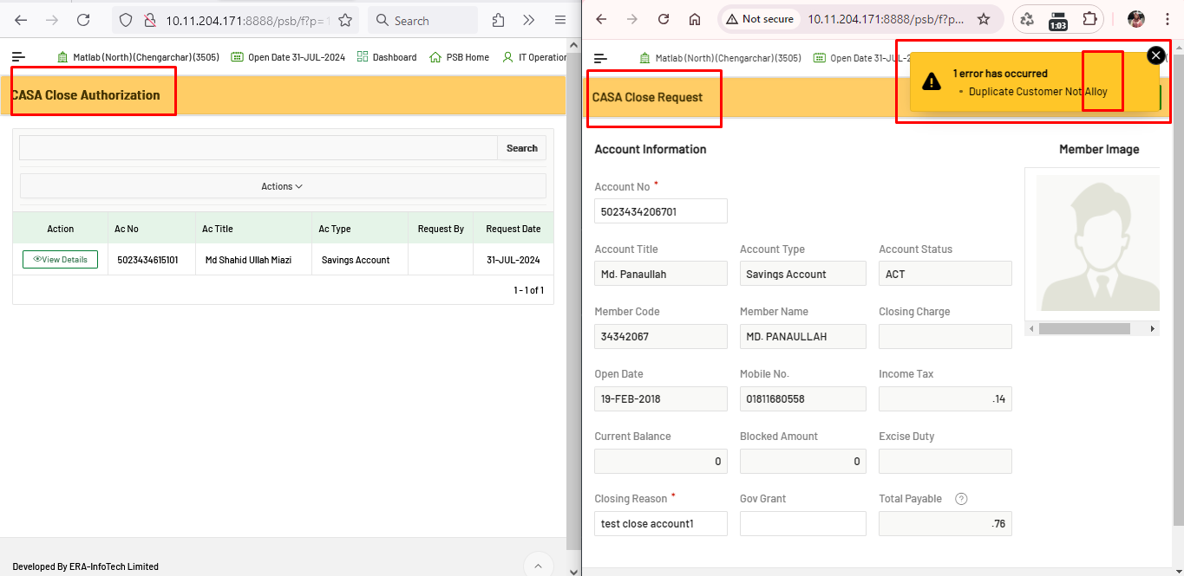

1. Database it's showing current balance of 100, but in the report the balance shows 0.

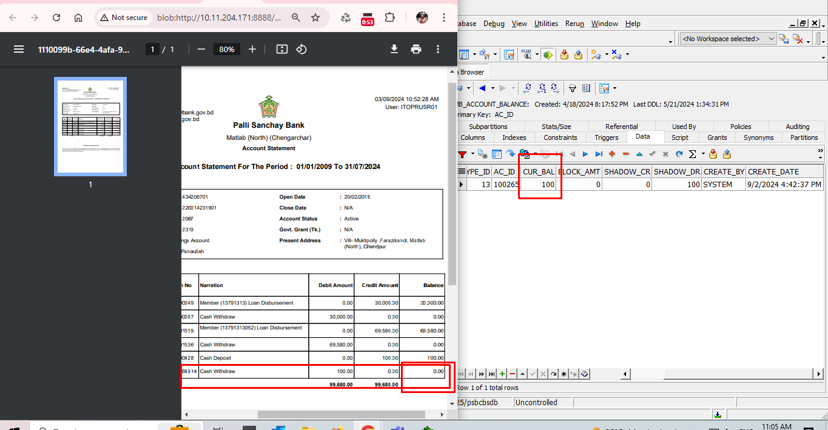

Gl a/c no: 1007001003004

Parent gl: 1007001003000

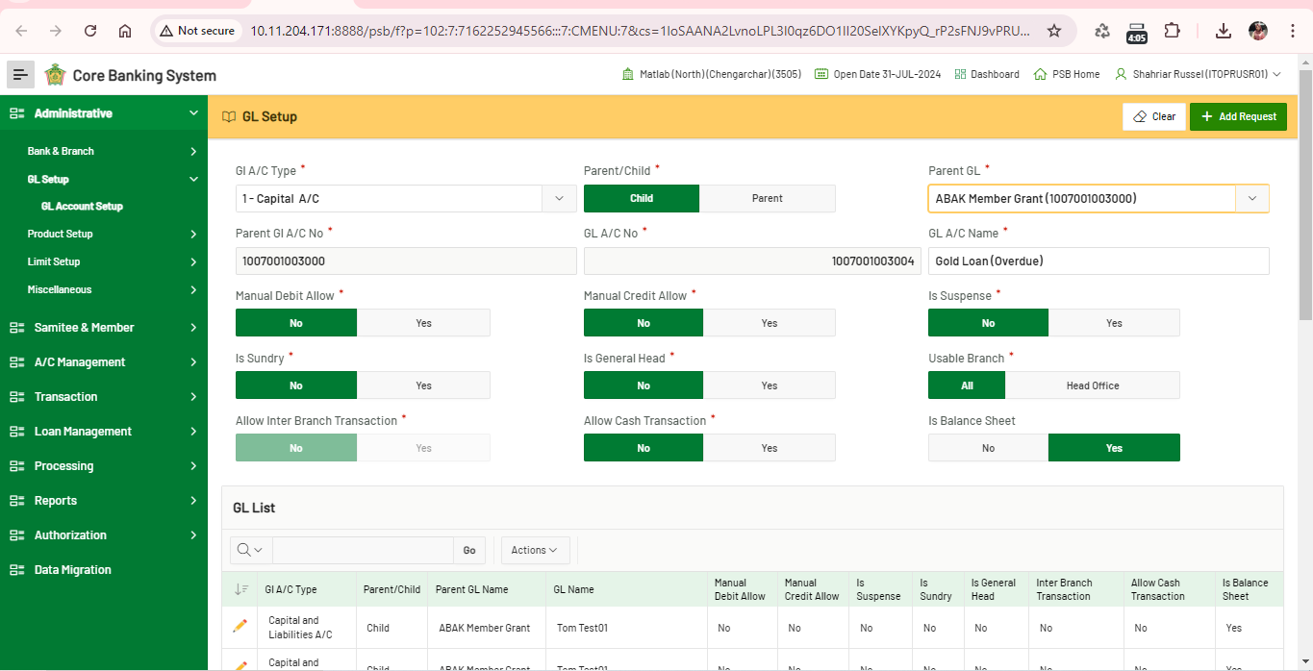

Gold Silver Loan (Overdue)

Gl a/c no: 1014000000000

Parent gl: 1000000000000

